Shadow of the Cross Evangelical Lutheran Church

20805 Middlebelt Rd, Farmington Hills, MI (248) 474-0675

Reverend Brian C. Dupre, Pastor, 313 683-3133

Veronica Green: Office Assistant, Dawn Kivimaki: Office Assistant, Davene Sexton:

Bookkeeper, Nancy Faith: Organist/Choir Director, Jessica Rose: Praise Choir Director

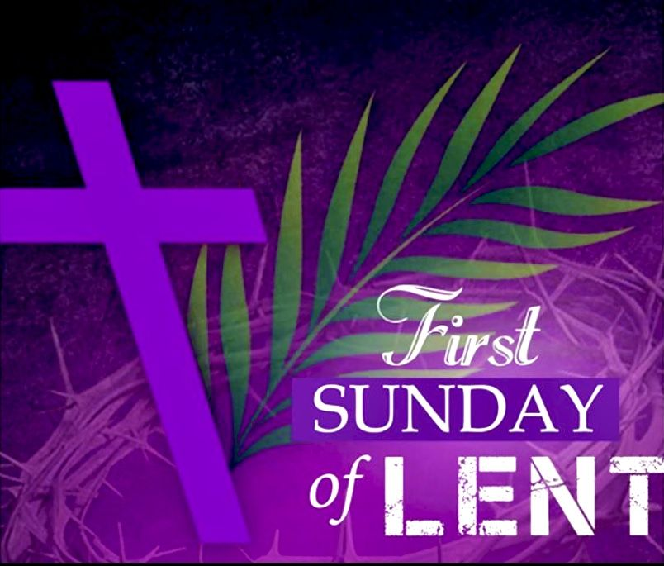

**DIVINE SERVICE**

***Setting Three***

***Setting Two Modified***

*Standing in the Shadow of the Cross*

*Standing in the Shadow of the Cross*

# The First Sunday in Lent

](about:blank)

# Sunday March 9, 2025

Processional Hymn:  LSB # 669 “Come, We That Love the Lord”

1. Come, we that love the Lord, and let our joys be known;   
join in a song with sweet accord, join in a song with sweet accord

and thus surround the throne, and thus surround the throne 

**Refrain:** We’re marching to Zion, Beautiful, beautiful Zion

We’re marching upward to Zion, the beautiful city of God

2. Let those refuse to sing who never knew our God;   
but children of the heavenly King, but children of the heavenly King

may speak their joys abroad, may speak their joys abroad**. Refrain**:

3. The hill of Zion yields a thousand sacred sweets   
before we reach the heavenly fields, before we reach the heavenly fields  
or walk the golden streets or walk the golden streets. **Refrain:**

4. Then let our songs abound, and every tear be dry;   
we're marching through Emmanuel's ground, we're marching through Emmanuel's ground, to fairer worlds on high, to fairer worlds on high. **Refrain:**

Greeting and Announcements

Confession and Absolution

P In the name of the Father and of the T Son and of the Holy Spirit.

C **Amen.**

P Beloved in the Lord! Let us draw near with a true heart and confess our sins unto God our Father, imploring Him in the name of our Lord Jesus Christ to grant us forgiveness.

P Our help is in the name of the Lord,

C **who made heaven and earth.**

P I said, I will confess my transgressions to the Lord,

C **and You forgave the iniquity of my sin.**

**Silence please for reflection on God's Word and for self-examination.**

P O almighty God, merciful Father,

C **I, a troubled and penitent sinner, confess unto You all my sins and iniquities with which I have ever offended You and for which I justly deserved Your punishment. But I am sorry for them and repent of them and pray for Your boundless mercy. For the sake of the suffering and death of Your Son, Jesus Christ, be gracious and merciful to me, a poor, sinful being. Forgive my sins, give me Your Holy Spirit for the amendment of my sinful life, and bring me to life everlasting. Amen**

P God is merciful and gracious, granting forgiveness through Jesus Christ to all who confess their sin. As a called and ordained minister of the Christian Church and by the authority of Christ, I therefore declare to you the entire forgiveness of all your sins, in the name of the Father and of the T Son and of the Holy Spirit.

C **Amen.**

Hymn of Praise:TFBF # 83 “Oh, How He Loves You and Me”

1. Oh, how He loves you and me, (*2x)*

He gave His life, what more could He give; Oh, how He loves you, Oh, how He loves me, Oh, how He loves you and me.

2. Jesus to Calv'ry did go, His love for mankind to show.

What He did there brought hope from despair.

Oh, how He loves you, Oh, how He loves me, Oh how He loves you and me.

***The Sunday school students are released to their teachers.***

Service of the Word

##### Introit *Ps. 91:9-13; antiphon: Ps. 91:15-16*

P When he calls to me, I will answer him; I will be with him in trouble;

C **I will rescue him and honor him**

P With long life I will satisfy him

C **and show him my salvation.**

P Because you have made the Lord your dwelling place

C **the Most High who is my refuge**

P no evil shall be allowed to befall you

C **no plague come near your tent.**

P For he will command his angels concerning you

C **to guard you in all your ways**

P On their hands they will bear you up,

C **lest you strike your foot against a stone.**

P You will tread on the lion and the adder;

C **the young lion and the serpent you will trample uderfoot**

C **Glory be to the Father and to the Son and to the Holy Spirit;**

**as it was in the beginning, is now, and will be forever. Amen.**

P When he calls to me, I will answer him; I will be with him in trouble;

C **I will rescue him and honor him**

P With long life I will satisfy him

C **and show him my salvation.**

Salutation and Collect of the Day

P The Lord be with you.

C **And also with you.**

P Let us pray.

O Lord God, You led Your ancient people through the wilderness and brought them to the promised Land. Guide the people of Your Church that following our Savior we may walk through the wilderness of this world toward the glory of the world to come; through Jesus Christ, Your Son, our Lord, who lives and reigns with You and the Holy Spirit, one God, now and forever.

C **Amen.**

**Please be seated**

Old Testament Reading*Deuteronomy 26:1-11*

“When you come into the land that the Lord your God is giving you for an inheritance and have taken possession of it and live in it, **2**you shall take some of the first of all the fruit of the ground, which you harvest from your land that the Lord your God is giving you, and you shall put it in a basket, and you shall go to the place that the Lord your God will choose, to make his name to dwell there. **3**And you shall go to the priest who is in office at that time and say to him, ‘I declare today to the Lord your God that I have come into the land that the Lord swore to our fathers to give us.’ **4**Then the priest shall take the basket from your hand and set it down before the altar of the Lord your God.

**5**“And you shall make response before the Lord your God, ‘A wandering Aramean was my father. And he went down into Egypt and sojourned there, few in number, and there he became a nation, great, mighty, and populous. **6**And the Egyptians treated us harshly and humiliated us and laid on us hard labor. **7**Then we cried to the Lord, the God of our fathers, and the Lord heard our voice and saw our affliction, our toil, and our oppression. **8**And the Lord brought us out of Egypt with a mighty hand and an outstretched arm, with great deeds of terror,[[a](https://www.biblegateway.com/passage/?search=Deuteronomy+26%3A1-11&version=ESV#fen-ESV-5575a)] with signs and wonders. **9**And he brought us into this place and gave us this land, a land flowing with milk and honey. **10**And behold, now I bring the first of the fruit of the ground, which you, O Lord, have given me.’ And you shall set it down before the Lord your God and worship before the Lord your God. **11**And you shall rejoice in all the good that the Lord your God has given to you and to your house, you, and the Levite, and the sojourner who is among you.

A This is the Word of the Lord.

C **Thanks be to God.**

Epistle*Romans 10:8b-13*

“The word is near you, in your mouth and in your heart” (that is, the word of faith that we proclaim); **9**because, if you confess with your mouth that Jesus is Lord and believe in your heart that God raised him from the dead, you will be saved. **10**For with the heart one believes and is justified, and with the mouth one confesses and is saved. **11**For the Scripture says, “Everyone who believes in him will not be put to shame.” **12**For there is no distinction between Jew and Greek; for the same Lord is Lord of all, bestowing his riches on all who call on him. **13**For “everyone who calls on the name of the Lord will be saved.”

A This is the Word of the Lord.

C **Thanks be to God.**

Special Music – SOTC Choir “I Want Jesus To Work With Me”

**Please stand**

Hymn: # 98 TFBF “Open My Eyes, Lord”

1. Open our eyes, Lord, we want to see Jesus, to reach out and touch Him and say that we love Him. 2. Open our ears, Lord And help us to listen, Open our eyes, Lord

We want to see Jesus.

1.

Holy Gospel *Luke 4:1-13*

P The Holy Gospel according to St. Luke, the fourth chapter.

C **Glory to You, O Lord.**

Jesus, full of the Holy Spirit, returned from the Jordan and was led by the Spirit in the wilderness **2**for forty days, being tempted by the devil. And he ate nothing during those days. And when they were ended, he was hungry. **3**The devil said to him, “If you are the Son of God, command this stone to become bread.” **4**And Jesus answered him, “It is written, ‘Man shall not live by bread alone.’” **5**And the devil took him up and showed him all the kingdoms of the world in a moment of time,**6**and said to him, “To you I will give all this authority and their glory, for it has been delivered to me, and I give it to whom I will. **7**If you, then, will worship me, it will all be yours.” **8**And Jesus answered him, “It is written, “‘You shall worship the Lord your God, and him only shall you serve.’” **9**And he took him to Jerusalem and set him on the pinnacle of the temple and said to him, “If you are the Son of God, throw yourself down from here, **10**for it is written, “‘He will command his angels concerning you, to guard you,’ **11**and “‘On their hands they will bear you up, lest you strike your foot against a stone.’” **12**And Jesus answered him, “It is said, ‘You shall not put the Lord your God to the test.’” **13**And when the devil had ended every temptation, he departed from him until an opportune time.

P This is the Gospel of the Lord.

C **Praise to You, O Christ.**

***Please be seated***

Hymn: LSB # 419 “Savior, When in Dust to Thee”

1. Savior, when in dust to Thee low we bow adoring knee;  
when, repentant, to the skies scarce we lift our weeping eyes;  
O, by all Thy pains and woe, suffered once for us below,  
bending from Thy throne on high, hear our penitential cry!

2. By Thy helpless infant years, by Thy life of want and tears,  
by Thy days of deep distress in the savage wilderness,  
by the dread, mysterious hour of the insulting tempter's pow'r,  
turn, O, turn a fav'ring eye; hear our penitential cry!

3. By Thine hour of dire despair, by Thine agony of prayer,  
by the cross, the nail, the thorn, piercing spear, and torturing scorn,  
by the gloom that veiled the skies o'er the dreadful sacrifice,  
listen to our humble sigh; hear our penitential cry!

4. By Thy deep expiring groan, by the sad sepulchral stone,  
by the vault whose dark abode held in vain the rising God,  
O, from earth to heav'n restored, mighty, reascended Lord,  
bending from Thy throne on high, hear our penitential cry!

Sermon: “The Temptation of Jesus”

Sermon Text: Luke 4:1-13

**Please stand**

Apostles' Creed

C **I believe in God, the Father Almighty,**

**maker of heaven and earth.**

**And in Jesus Christ, His only Son, our Lord,**

**who was conceived by the Holy Spirit,**

**born of the virgin Mary, suffered under Pontius Pilate,**

**was crucified, died and was buried. He descended into hell.**

**The third day He rose again from the dead.**

**He ascended into heaven**

**and sits at the right hand of God the Father Almighty.**

**From thence He will come to judge the living and the dead.**

**I believe in the Holy Spirit, the holy Christian Church,**

**the communion of saints, the forgiveness of sins,**

**the resurrection of the body, and the life T everlasting. Amen.**

**Please be seated**

Offering

**Please stand.**

Offertory *LSB 192*

C **Create in me a clean heart, O God, and renew a right spirit within me. Cast**

**me not away from Thy presence and take not Thy Holy Spirit from me. Restore**

**unto me the joy of Thy salvation and uphold me with Thy free spirit. Amen.**

Prayer of the Church

P Feel free to remain standing, be seated, or come to the altar to pray

Hymn: TFBF # 247 “Lord, Listen to Your Children Praying”

C **Lord, listen to Your children praying; Lord, send Your Spirit in this place. Lord**

**listen to Your children praying; send us love, send us power, send us grace.**

P You may return to your seats, the Lord has heard your prayers (**All stand)**